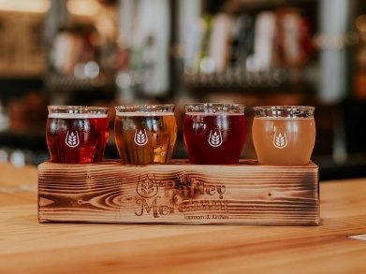
Winery, Brewery, Distillery, and Cidery
GETTING STARTED CHECKLIST
- Obtain Federal Employer Identification Number (EIN) or use individual’s social security number
- Provide copy of zoning clearance from Community Development
- Provide trade name and/or business registration from State Corporation Commission (If applicable)
- Complete and submit Business License Application
- Complete and submit Business Tangible Personal Property Return
Farm Winery & Cidery : “Farm winery” means an establishment located on a farm in the Commonwealth of Virginia on land zoned agricultural with a producing vineyard, orchard, or similar growing area and with facilities and bottling on the premises where the owner or lessee manufactures a product that may include, but not limited to, wine, cider, sake, or mead that contains no more than 21 percent alcohol by volume. Virginia Code §4.1-100
Winery & Cidery : “Winery” means an establishment located in the Commonwealth of Virginia on land zoned agricultural with agreements for purchasing grapes or other fruits from agricultural growers, and with facilities for fermenting and bottling wine on the premises where the owner or lessee manufactures a product that may include but is not limited to wine, cider, sake, or mead that contains not more than 21 percent alcohol by volume. Virginia Code §4.1-100
Brewery: “Brewery” means every person manufacturing any malt beverage, has title to any such malt beverage products, and has the right to distribute under its own brand any malt beverage product. Virginia Code §4.1-500
Distillery: “Distillery” means every person that manufactures alcoholic beverages (such as whiskey, moonshine, etc.) other than wine and beer, and to sell and deliver or ship the same. Virginia Code §4.1-206.1
Business License Reporting Requirements (Annual Renewal due March 1)
FARM WINERY & CIDERY WINERY & CIDERY BREWERY DISTILLERY
Gross receipts from the sale  of products grown and produced by the entity and offered for sale or wholesale by entity. | EXEMPT | EXEMPT | EXEMPT | EXEMPT
Gross receipts from sale of products that are not grown or manufactured or produced by the entity. | TAXABLE | TAXABLE | TAXABLE | TAXABLE
Gross receipts from the operation of separate lines of business activities such as, but not limited to, special activities, receptions, other social functions, event rentals, wedding services, restaurants, and lodging facilities. | TAXABLE | TAXABLE | TAXABLE | TAXABLE

Winery, Brewery, Distillery, and Cidery 

BUSINESS TANGIBLE PERSONAL PROPERTY AND MACHINERY & TOOLS REPORTING REQIURMENTS (Annual filing due May 1)
FARM WINERY & CIDERY WINERY & CIDERY BREWERY DISTILLERY
Farm machinery used in the growing and harvesting process on the property. | EXEMPT | N/A | EXEMPT | EXEMPT
Machinery and tools utilized in the manufacturing process at the location, including computers used as part of the manufacturing. | EXEMPT | TAXABLE | TAXABLE | TAXABLE
Business equipment used in ancillary businesses. Ancillary exemptions may include tasting room furniture and equipment. | EXEMPT | EXEMPT | EXEMPT | EXEMPT
Furniture and fixtures used in manufacturing (included, but not limited to, equipment used in a corporate headquarters) to manufacture products on premise. | EXEMPT | EXEMPT | EXEMPT | EXEMPT
Business equipment used in separate lines of businesses such as, but not limited to, special activities, receptions, other social functions, event rental, wedding services, restaurants, and lodging faculties. | TAXABLE | TAXABLE | TAXABLE | TAXABLE

